The
Quality Policy
of
Newcastle Furniture Service
(A service of Your Homes Newcastle)
Your Homes Newcastle (YHN) is an Arms Length Management Organisation (ALMO) set up on 1st April 2004 with responsibility for the management of 28,000 council homes in Newcastle. Newcastle Furniture Service (NFS) was set up in 1989 to help council tenants live in their homes. The service has expanded into the largest furnished tenancy provider in the UK and supplies over 11,500 homes throughout the UK. The furniture supplied includes cookers, washing machines, beds, sofas, crockery and many other items which will help tenants live in their homes.

NFS are dedicated to providing our tenants and customers with quality products and services, giving value for money and complete satisfaction.

In order to achieve this NFS are committed to a continuous improvement culture throughout the organisation based on stated Company objectives and the EN ISO 9001: 2015 standard. We commit to the continual review and improvement of the quality management system.

NFS conduct an analysis of their operational and strategic risks, client requirements and statutory and regulatory requirements, from this quality objectives are established to mitigate risk and enhance customer satisfaction.

We aim to fully understand (and wherever possible exceed) the stated requirements of our clients, colleagues and other Interested Parties.

NFS view Quality as an essential company framework to gain a competitive advantage, as well as reinforcing and enhancing the company’s reputation and image.

Signed: 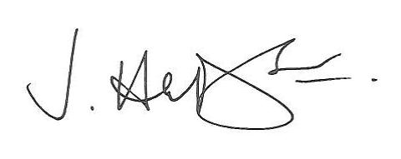

James Hudson

Assistant Director – Commercial

Date: 14th August 2021

