The
Environmental Policy
of
Newcastle Furniture Service
(A service of Your Homes Newcastle)
Your Homes Newcastle (YHN) is an Arms Length Management Organisation (ALMO) set up on 1st April 2004 with responsibility for the management of 28,000 council homes in Newcastle. Newcastle Furniture Service (NFS) was set up in 1989 to help council tenants live in their homes. The service has expanded into the largest furnished tenancy provider in the UK and supplies over 11,500 homes throughout the UK. The furniture supplied includes cookers, washing machines, beds, sofas, crockery and many other items which will help tenants live in their homes. Newcastle Furniture Service (NFS) recognises that its activities impact upon the environment both through its internal operations and through its influences and effects on the wider community. It acknowledges a responsibility for, and a commitment to, protection of the environment (i.e. pollution prevention) at all levels.

We will comply fully with environmental legislation as well as the requirements of Interested Parties and in addition are committed to continued efforts to: -

- Promote environmental policies and practises in all of its client organisations.
- Increase awareness of environmental responsibilities among all employees.
- Minimise waste and harmful impact, and develop and operate environmentally sound waste management procedures,
- Promote a purchasing policy that will give preference, as far as practicable to those products and services that cause least harm to the environment.
- Avoid wherever practical the use of environmentally damaging substances, materials and processes.
- Promote the efficient use of energy and water among both employees and clients
- Promoting a culture of continuous improvement based upon the company’s stated objectives and the ISO 14001: 2015 standard.

Signed:
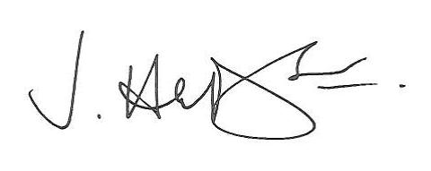

James Hudson

Assistant Director Commercial Strategy and Growth

Date: 4th October 2021

